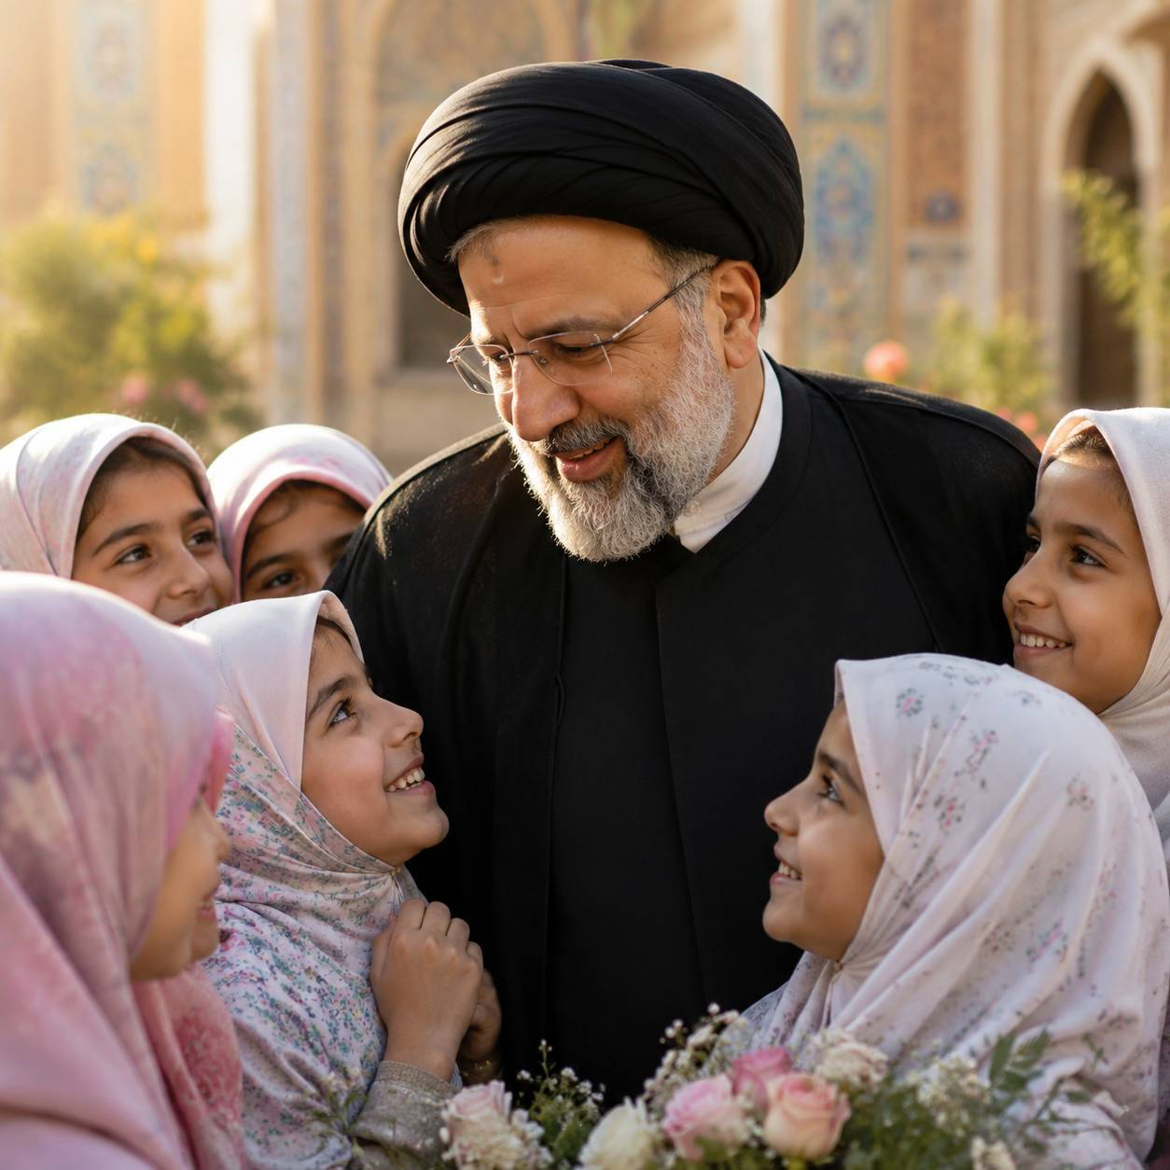
Ayatollah Raisi was a distinguished figure of faith, dignity, and devoted public service. His life reflected commitment, responsibility, and a deep sense of duty toward the nation and its people. He will be remembered with respect for his steadfast character, principled leadership, and the enduring mark he left through a lifetime of service.

With his martyrdom, the memory of Ayatollah Raisi became even more deeply rooted in the hearts of many. He is honored as a man of conviction and sacrifice, whose legacy continues to stand as a reminder of sincerity, perseverance, and devotion to a higher cause.

انجمن‌علمی‌ دانشجویی زبان انگلیسی دانشگاه امام‌ صادق(ع) پردیس‌ خواهران
🆔@english_isuw
هسته پژوهشی نگارش مقالات آکادمیک
🆔@penandresearchcore

