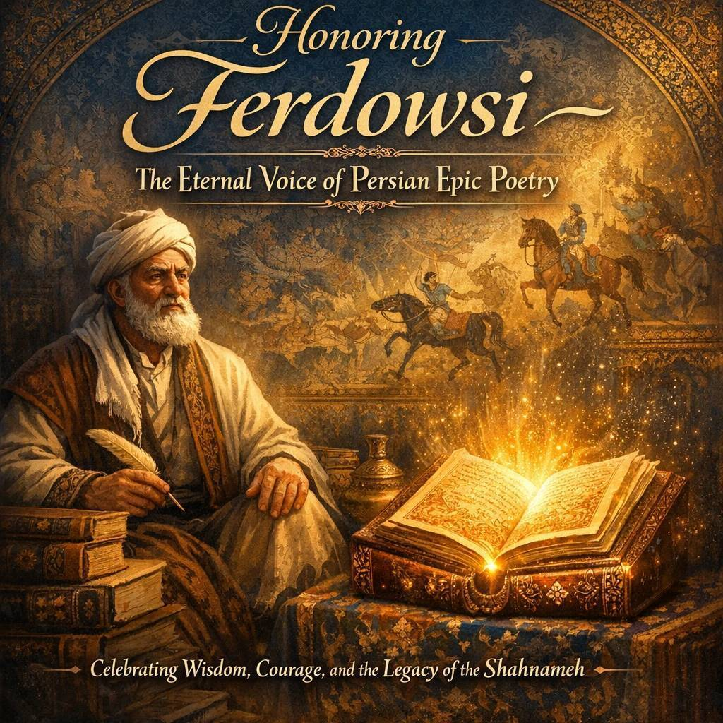
On Ferdowsi Day, we honor the legacy of Abolqasem Ferdowsi, the legendary Persian poet whose masterpiece, the Shahnameh, preserved the language, history, and spirit of Iran for generations. His timeless words continue to inspire millions and remind us of the enduring power of culture, wisdom, and poetry. Today, we proudly commemorate the voice that kept Persian heritage alive through the centuries.

