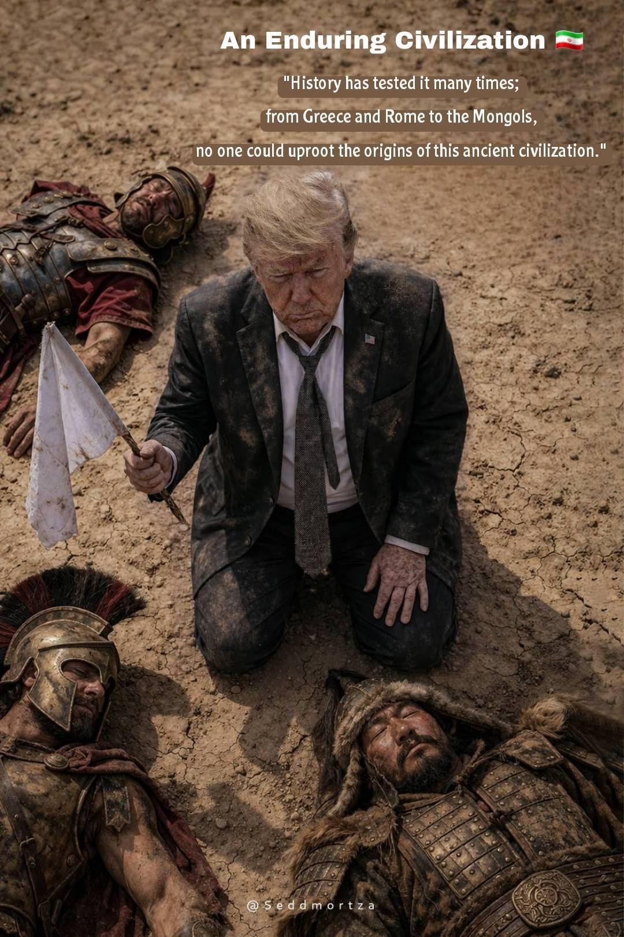
Iran: An Enduring Civilization 🇮🇷"
"History has tested it many times; from Greece and Rome to the Mongols, no one could uproot the origins of this ancient civilization."

produced by Miss Suezie

