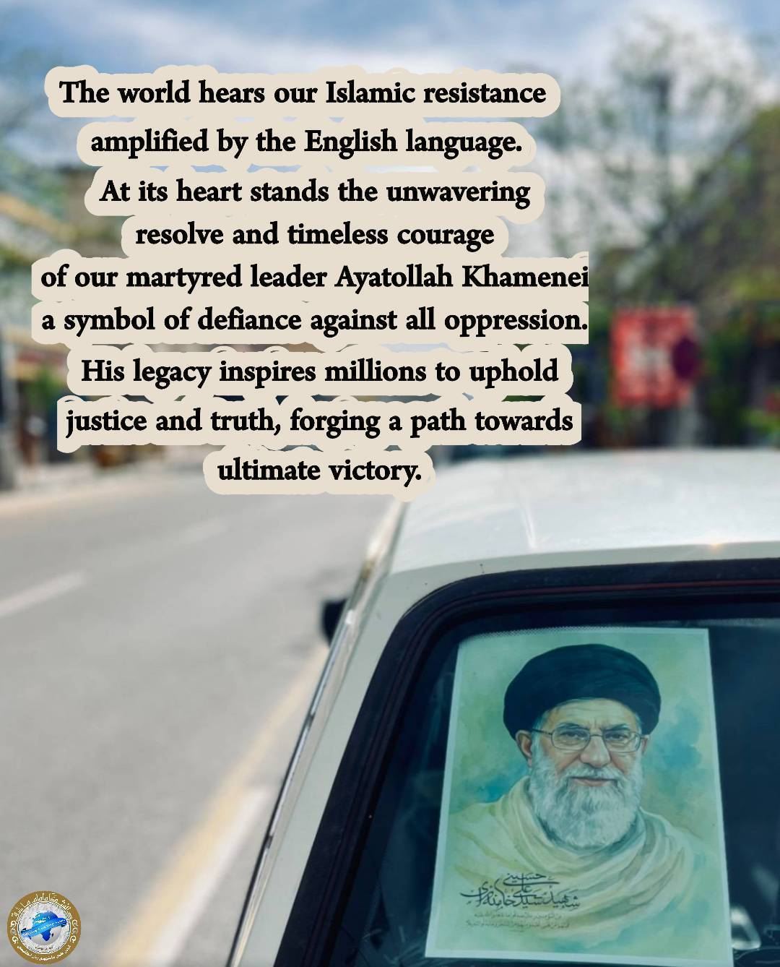

The world hears our Islamic resistance amplified through the English language. At its heart stands the unwavering resolve and timeless courage of our martyred leader, Ayatollah Khamenei, a symbol of defiance against all oppression. His legacy inspires millions to uphold justice and truth, forging a path toward ultimate victory.

produced by Miss Bazrafshan

