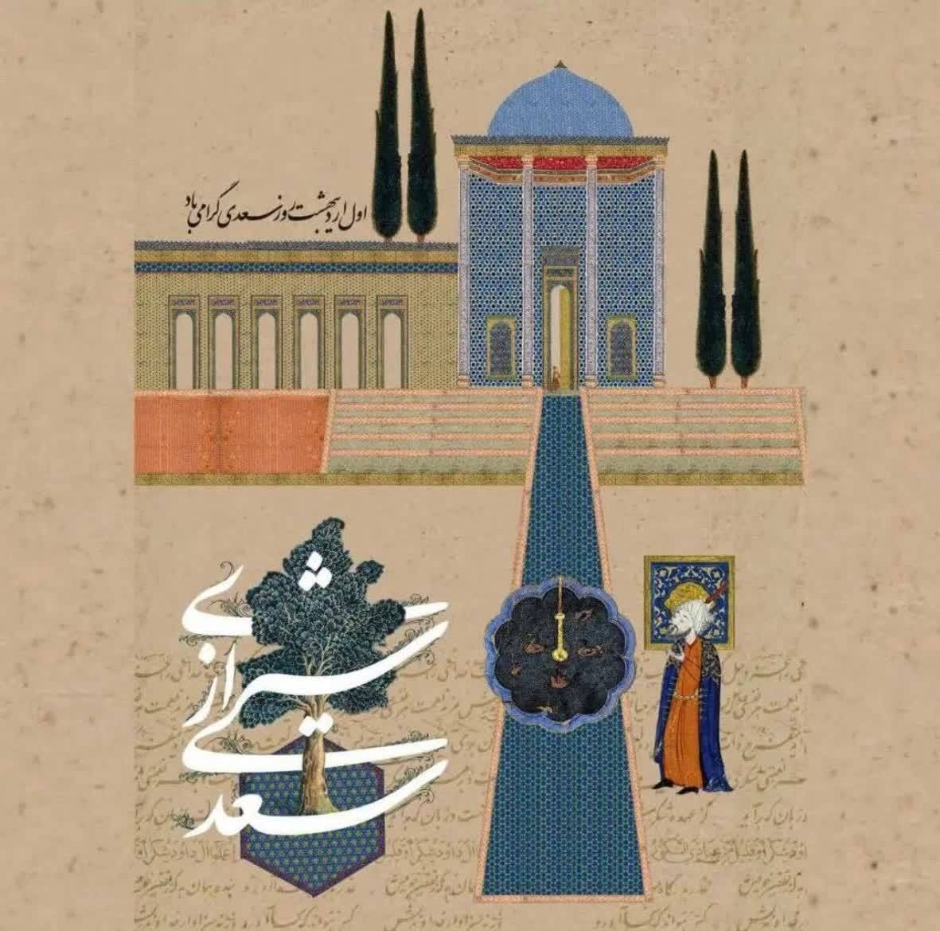
Sadi, the renowned Persian poet of the 7th century AH, remains one of the most influential voices in classical literature. His masterpieces, Gulistan and Bustan, blend storytelling with moral insight, offering reflections on humanity, justice, love, and wisdom. Sadi’s eloquence and clarity make his words timeless speaking to readers across cultures and eras with remarkable freshness.
As a testament to the richness of Persian civilization, Sadi embodies the depth, beauty, and intellectual power of Iran’s cultural heritage. His teachings continue to inspire generations around the world, reminding us of the universal values that unite humanity. Exploring Sadi’s works is not just reading poetry it is stepping into a legacy of compassion, refinement, and enduring wisdom.

